**Lesson Summary and Revision Notes: Week 10**

Define What is a Language Translator.

* A software program that is used to translate a source program written in any language is known as translators.

Name the three types of Language Translators available

* - Assemblers
* - Compilers
* - Intepreters

Characteristics of an Assembler

* Assembly language is a low level programming language.
* Assembly language programs are machine dependent; they are not portable from one type of computer/chip to another.

Similarities and differences between Assemblers, Compiler and Interpreters

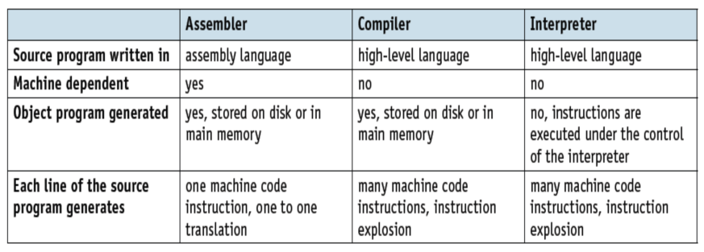

Define What is Data Privacy

Data privacy is defined as the protection of personal data from those who should not have access to it and the ability of individuals to determine who can access their personal information.

Define What is Security and how it can be achieved

Data security: refers to the prevention of unauthorised access to data, as well as to the data recovery methods if it is lost.

Data security can be achieved through:

* User Account Authentication (eg: screen prompt for username and password)
* User Account Access Rights (eg: each user account is linked to the appropriate level of access)
* Use of Passwords (eg: restrict access to data or systems)
* Digital Signatures (eg: electronic signature for user authentication)
* Firewalls (eg: network security system to monitor network traffic)
* Antivirus Software / Anti-Spyware
* Encryption (eg: converting data into a code to prevent authorised access)

Password Authentication

* A strong and unique password should be used so that it's harder for an attacker to guess.
* To ensure password safety, the longer and more complex the password is, the better.
* It's a good practice to enforce certain minimum requirements when asking users to create a new password.
* To enforce password strength, a set of rules can be enforced to decide what a password must satisfy.

Password should be secure and this can be achieved through:

* Running anti-spyware to ensure password is not relayed to unauthorised person
* Changing the password regularly
* Making sure password are difficult to guess or crack

Passwords are grouped as either strong (hard to crack or guess) or weak. Strong passwords should contain:

* at least one capital letter
* at least one numerical value
* at least one other keyboard character (such as @, *, &)

Measures to Ensure Data Privacy

* Password Authentication
* Firewall
* Encryption
* Antivirus
* Biometrics

Risk to Security of Stored Data

* It is important to safeguard digital information throughout its entire life cycle to protect it from corruption, theft, or unauthorized access.
* Some of the key risks to the security of stored data includes:
* Hacking (eg: illegal access to a computer without the user permission)
* Viruses (eg: code that replicate themselves with intention of corrupting or deleting files)
* Worms (eg: standalone virus that replicate themselves and spread to other computers)
* Logic Bombs (eg: code that activate in a computer when certain conditions are met)
* Trojan Horses (eg: malicious programs that disguise themselves as legitimate software)
* Spyware (eg: Software that gathers information by monitoring key presses on the user’s keyboard.)
* Phishing (eg: an attacker, acting as a trusted entity, fool a victim into opening an email, instant message, or text message)

**Data Validation**

**Data Validation**: defined as the practice of checking the integrity, accuracy and structure of data before it is used for a business operation.

The most common types of data validation are:

* type validation (eg: ensure non-numeric data is not input into numeric only field)
* range validation (eg: check data withn lower and upper limit: age should not be negative value)
* format validation (eg: data entered in agreed format, date should be dd/mm/yyyy)
* length validation (eg: check data has the required number of characters)
* presence validation (eg: check to ensure a data field is not left empty)
* existence validation (eg: check if data in database or file actually exists)
* limit check (eg: check the lower and upper limit of data, eg: age should not be negative value)
* consistency check (check data in two or more field matched correctly, eg: keying "Mrs" and choosing gender as "Female")
* uniqueness check (check that unique data such us Student_ID, Email_Address are not entered into system more than once)

What are the three factors of Computer Ethics ?

1) Intellectual property rights(eg: copying of software without the permission of the owner).

2) Privacy issues (eg: hacking or any illegal access to another person’s personal data).

3) Effect of computers on society (eg: job losses, social impacts etc).

Why it is necessary to produce a code of ethics to cover the computing and electonics industries ?

The Code is designed to inspire and guide the ethical conduct of all computing professionals and anyone who uses computing technology in an impactful way. It covers some of these areas:

* **The Public Interest**: A computing professionals should work together for the public good, and let everyone have access to IT, uphold standards and conduct themselves professionally and fairly at all times.
* **Professional Competence and Integrity**: A computing professional should have integrity and show competence, continuously learn and grow and never take on tasks that he or she don’t have the skills and resources to complete.
* **Duty to Relevant Authority**: A computing professional should work with due care and diligence, acting in their clients or company’s best interests at all times. They take personal and collective responsibility for their actions.
* **Duty to the Profession**: A computing professional should use their voice to help promote IT positively to the world. They support their IT colleagues and other members in their growth both personally and professionally.
* **Avoid harm**: A computing professional should mimize the possibility of indirectly or unintentionally harmimg others and to report any signs of system risks that might result in harm.
* **Be honest and trustworthy**:A computing professional should be transparent and provide full disclosure of all system capabilities, limitations, and potential problems to the appropriate parties.
* **Be fair and do not discriminate**: Computing professionals should foster fair participation of all people, including those of underrepresented groups.

Software copyright and privacy

Software is protected by copyright laws in much the same way as music CDs, videos and articles from magazines.

When software is purchased, there are certain rules that must be obeyed:

* It is illegal to make a software copy and sell it or give it away.
* Software cannot be used on a network or used on multiple computers without a multi-use licence.
* It is illegal to use coding from copyrighted software in your own software.
* It is illegal to rent out a software package without permission to do so.

Describe the two main types of software licensing

1) Commercial software

* Commercial software is available to customers for a fee, providing a licence for one genuine copy to be used on a single device, or a multi-use licence for multiple users (eg: Adobe Photoship)

2) Free Software and the Open Source Initiative

* Non-profit organisations that promote the benefits of giving users the freedom to run, copy, change and adapt software (eg:Libre Office Suite).
* Users are given the freedom to run the software, study the program source code and modify it, redistribute copies of the software and code modified by user to friends and family.

Explain what is meant by freeware and shareware

* **Freeware**: software a user can download from the internet free of charge.
  + Once the software has been downloaded, there are no fees associated with using the software (examples include: Adobe Reader, Skype and some media players).
* **Shareware**: software that allows users to try out some software free of charge for a trial period.
  + At the end of the trial period, the author of the software will request that the user pay a fee if you wish to continue using it.
  + Shareware is protected by copyright laws and users must not use the source code in any of their own software without permission.